A practical guide for the visual identification of Merino sheep with high density and length of wool

J.E. Watts, N. Jackson, J. Gordon and A. Penfold

16 February 2018

Table of Contents

1. Introduction
2. Whole animal
3. Fleece density
4. Fibre bundle
5. Follicle patterning
6. Fleece and fibre length
7. Crimp
8. No mulesing and no fly strike
9. Summary
10. References

**A practical guide for the visual identification of Merino sheep with high density and length of wool**

J.E. Watts, N. Jackson, J. Gordon and A. Penfold

1. **Introduction**

Merino sheep are almost unique among different breeds of sheep in having high levels of secondary wool follicle development. This is associated with high levels of dermal tissue development (Jackson and Watts 2018). As the skin expands, the skin needs to remain loose, otherwise wrinkle (folds) will form.

It appears that if two skin layers, the reticular dermis and underlying areolar tissue, are not bound together by collagen fibres, the skin will remain free of wrinkle, regardless of the extent of dermal tissue expansion.

If dermal tissue expansion is either high, moderate or low, and the skin is unattached (loose) or attached (fixed), then 6 different phenotypes (Table 1) are possible.

Table 1. The likely effects of dermal tissue expansion and skin suppleness on the gross appearance of Merino skin.

|  |  |  |
| --- | --- | --- |
| Dermal tissue expansion | Skin layers | |
| Unattached  (all plain bodied sheep) | Attached |
| High | Loose and highly expansive skin | Fixed and highly expansive skin (wrinkly) |
| Moderate | Loose and expansive skin | Fixed and expansive skin (pin wrinkle) |
| Low | Loose but non-expansive skin | Fixed and non-expansive skin (plain bodied sheep) |

The sheep types that fit these skin descriptions are:

* “SRS” (“soft rolling skin”) sheep, which are plain bodied animals with loose and highly expansive skins. The fleeces consist of very long and closely packed fibre bundles and thin staples. The wool is very soft, lustrous and has high crimp amplitude (“deep” crimp) and low crimp frequency (“bold” crimp). The sheep have high density and length (Paper 2 and Paper 3 references here) and are included in breeding programs.
* “semi SRS” sheep, which are plain bodied animals with loose and expansive skins. The fleeces consisting of long, thin staples of moderate packing. There are no fibre bundles. The wool is soft and semi-lustrous. The crimp amplitude is not as pronounced as for SRS sheep. These sheep rank next best for density and length and are also included in breeding programs.
* “pretty wool” sheep, which are plain bodied animals with loose but non-expansive skins. The fleeces consist of thin staples, similar in appearance to semi SRS, wool but of lower staple density and weight, and often shorter fleece length. These sheep, being of low density, are usually low in fleece weight, and excluded from breeding programs for that reason.
* “flat skin” sheep, which are plain bodied with fixed and non-expansive skins. The fleeces consist of large, lightweight staples of low packing density. The wool is neither soft or lustrous. The crimp amplitude is poorly defined. These sheep are usually excluded because of low density and high fibre diameter.
* “pin wrinkle” sheep are not plain bodied and have fixed and expansive skins. The fleeces consist of thick, heavyweight staples of high packing density and shorter length than the semi SRS and SRS types. The wool is sometimes soft and semi-lustrous and deeply crimped. Wax content is usually high and suint content (whiteness and yellowness of wool) variable. The sheep usually produce high fleece weights. However, rams of this type are avoided as we do not want to breed sheep with attached skin layers and predisposition to skin wrinkling. The ewe portion may sometimes be kept and joined to SRS rams as a corrective mating.
* “wrinkly” sheep are clearly not plain bodied, and have fixed and very expansive skins. The fleeces consist of even thicker and larger staples of shorter length, more wax and more suint than is seen in the “pin wrinkle” sheep. The wool is harsh, and lacks lustre and crimp definition. These sheep are culled.

Measurement standards for density and fibre diameter have been established for 4 of the 6 classing types from a field survey of 812 Merino stud rams in 45 flocks throughout Australia between 1986 and 1995 (Watts et al, 2017b).

SRS sheep have a mean density of 84.0 follicles per square millimetre, or 25 %, 51 % and 53% higher than the semi SRS sheep, wrinkly skin and flat skin sheep respectively. The S/P ratio of the SRS phenotype has a mean value of 44.1, or 29 %, 54% and 78% higher than the other phenotypes. The primary fibre diameter of the SRS phenotype has a mean value of 18.9 microns, or 0.9, 4.0 and 3.4 microns finer respectively than the other phenotypes. The secondary fibre diameter of the SRS phenotype has a mean value of 20.4 microns, or 1.3, 4.2 and 3.6 microns finer respectively than the other phenotypes.

The descriptions that follow are mainly about the SRS phenotype. For our breeding programs purposes, SRS sheep are recognised as the most advanced sheep for wool production and wool quality. It is also a sheep type that is naturally resistant to fly strike and does not require mulesing.

1. **The whole animal**

On distant examination, SRS and semi SRS sheep are recognised as open faced, plain bodied animals with floppy fleeces. The fleece part along the topline (Figure 1). The tips have a brushed appearance, especially evident down the sides of the body.

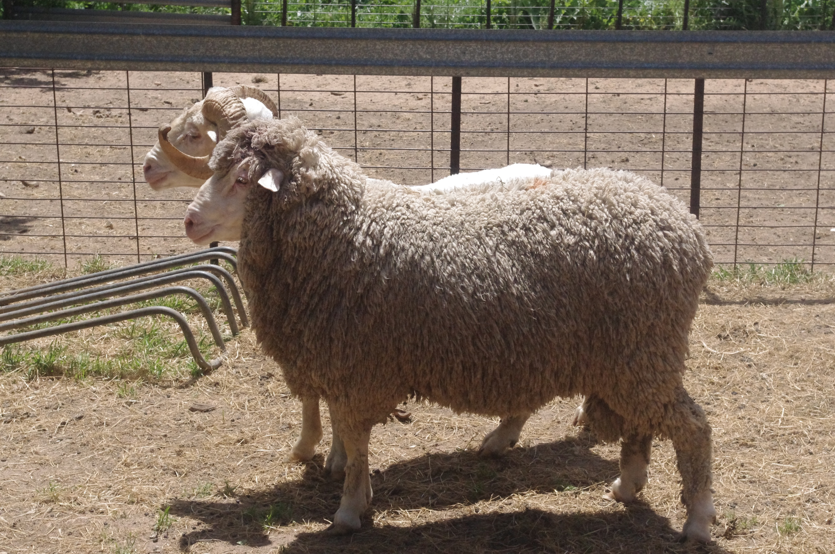

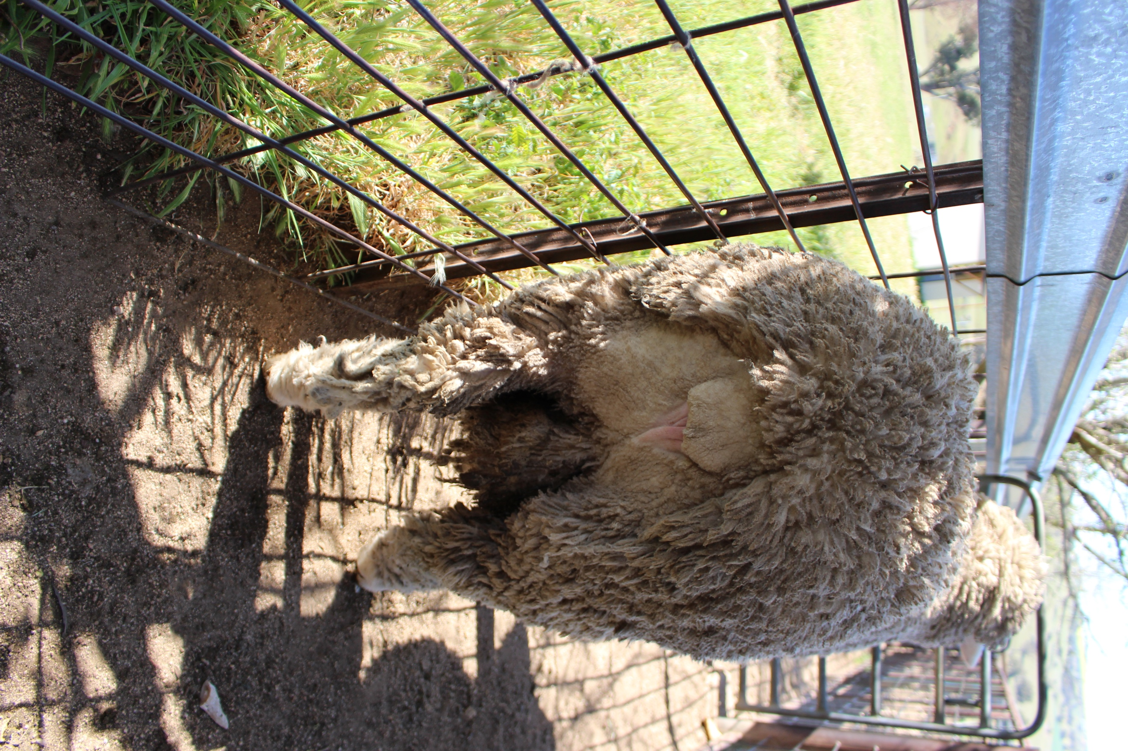

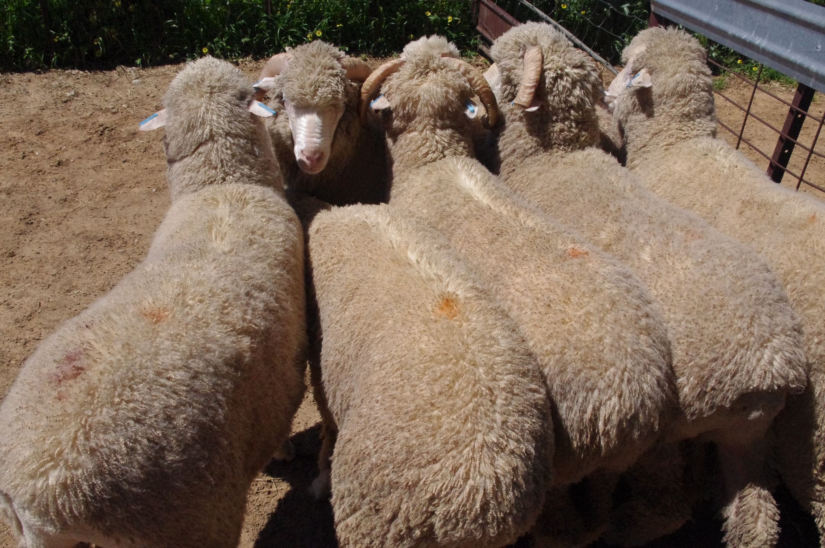

(Arcadia IMGP 8965.JPG)

**Figure 1. SRS and semi SRS Merino rams from the same medium wool flock. The top two photos feature the same 3 year old ram carrying 11 months wool growth. The bottom photo shows 12 months old rams with 5 months wool growth.**

The outer fleece surface of the SRS and semi SRS sheep consists of the ends of “thread-like” fibre bundles and thin staples with a deep and well defined crimp.

Fibre bundles are only about 1 square millimetre in cross-sectional area. Each bundle represents the fibres produced by a follicle group in the skin. The thin staples are usually less 5 square millimetres in cross-sectional area.

The breech region has no skin wrinkling. Often the sheep have bare breeches.

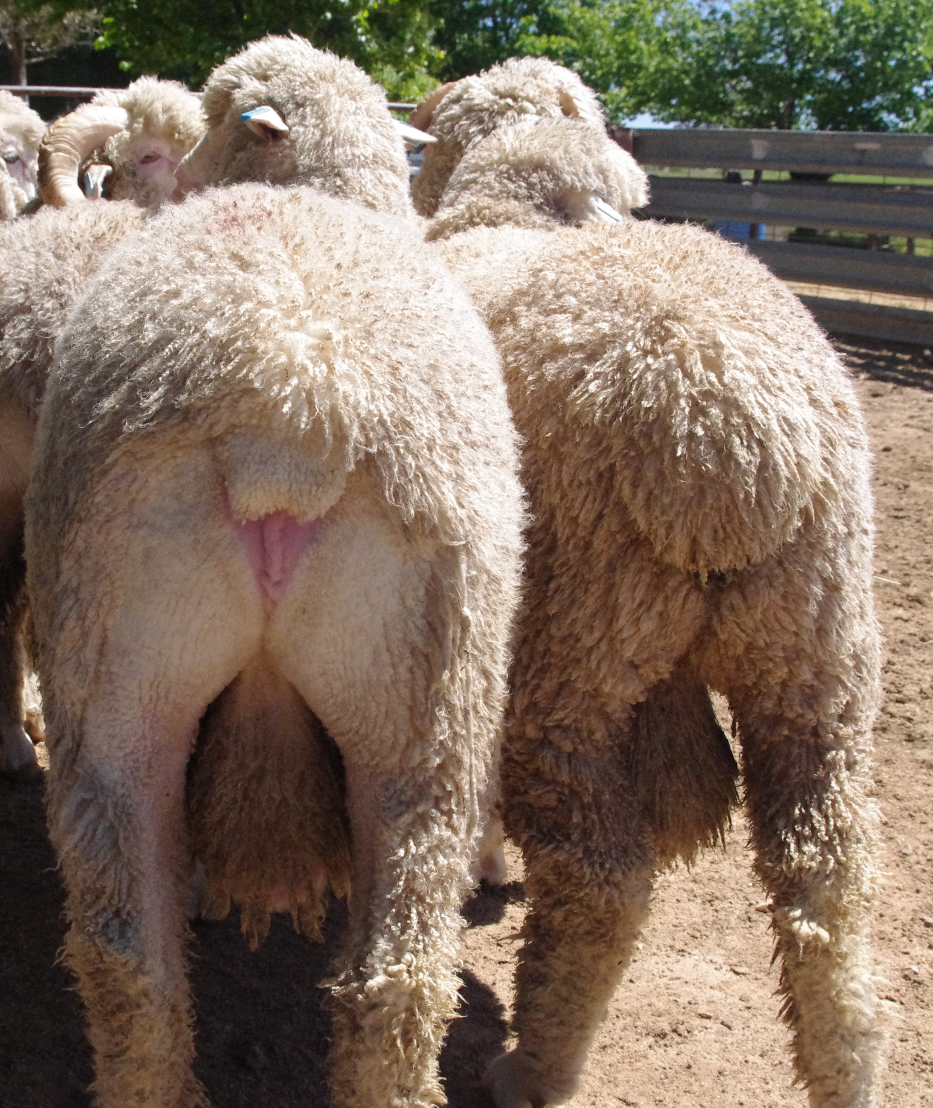

**Figure 2. SRS Merino rams, 12 months old and carrying 5 months wool growth. The sheep on the left has been crutched to show its wrinkle free and bare breech.**

When shorn, the smooth outer fleece surface of SRS and semi SRS sheep is mirrored by a skin surface that has no wrinkle or folds (Figure 3).

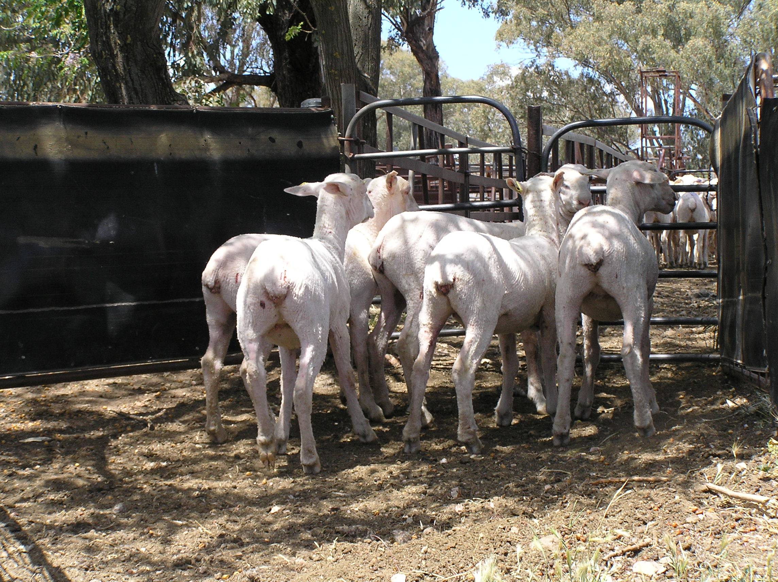

**Figure 3.** The wrinkle free skin of nine months old SRS Merino ewes (medium wool) immediately following shearing.

**T**he skin of the SRS sheep is easily extended, but less so in the semi SRS sheep. (Figure 4).

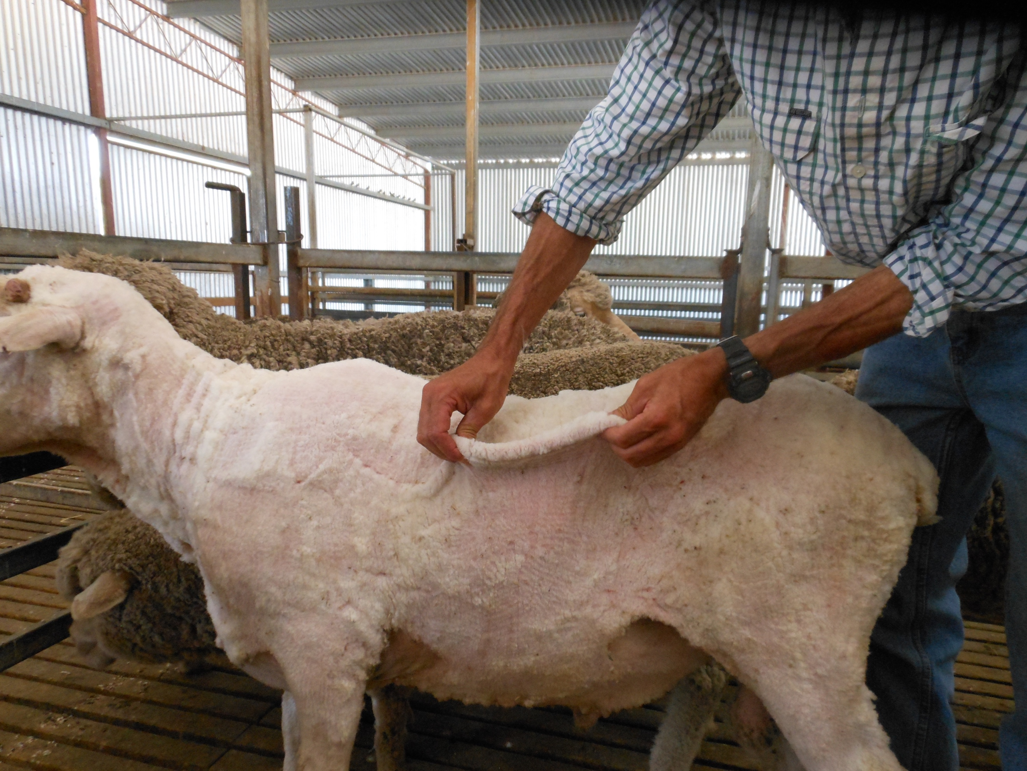



**Figure 4. Top: the loose skin on this plain bodied SRS Merino ram is highly expansive. Bottom: the loose skin of this semi SRS ram is loose but not as expansive.**

Early signs of skin wrinkling appear as corrugations running across the topline (Figure 5).



**Figure 5. Skin wrinkles have developed as striations across the topline of this “pin wrinkle” sheep.**

Pin wrinkle has developed further on the sheep shown in Figure 6.

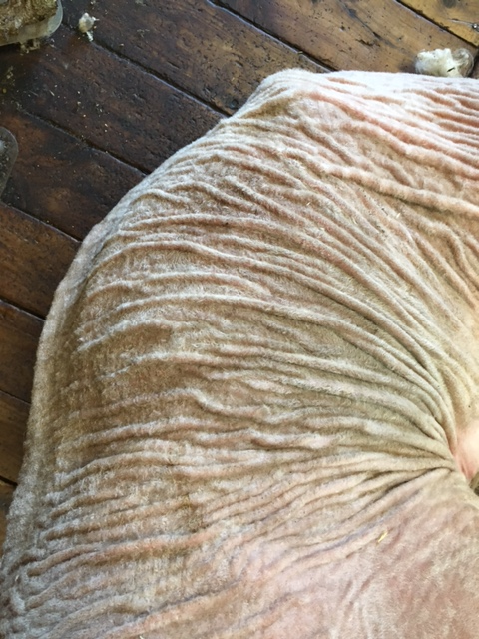

**Figure 6. A “pin wrinkle” Merino ewe, two years old. Note how the green stain caused by fleece rot bacteria has spread from the shoulders onto the belly.**

Extensive skin wrinkling is present on one of the sheep in Figure 7.

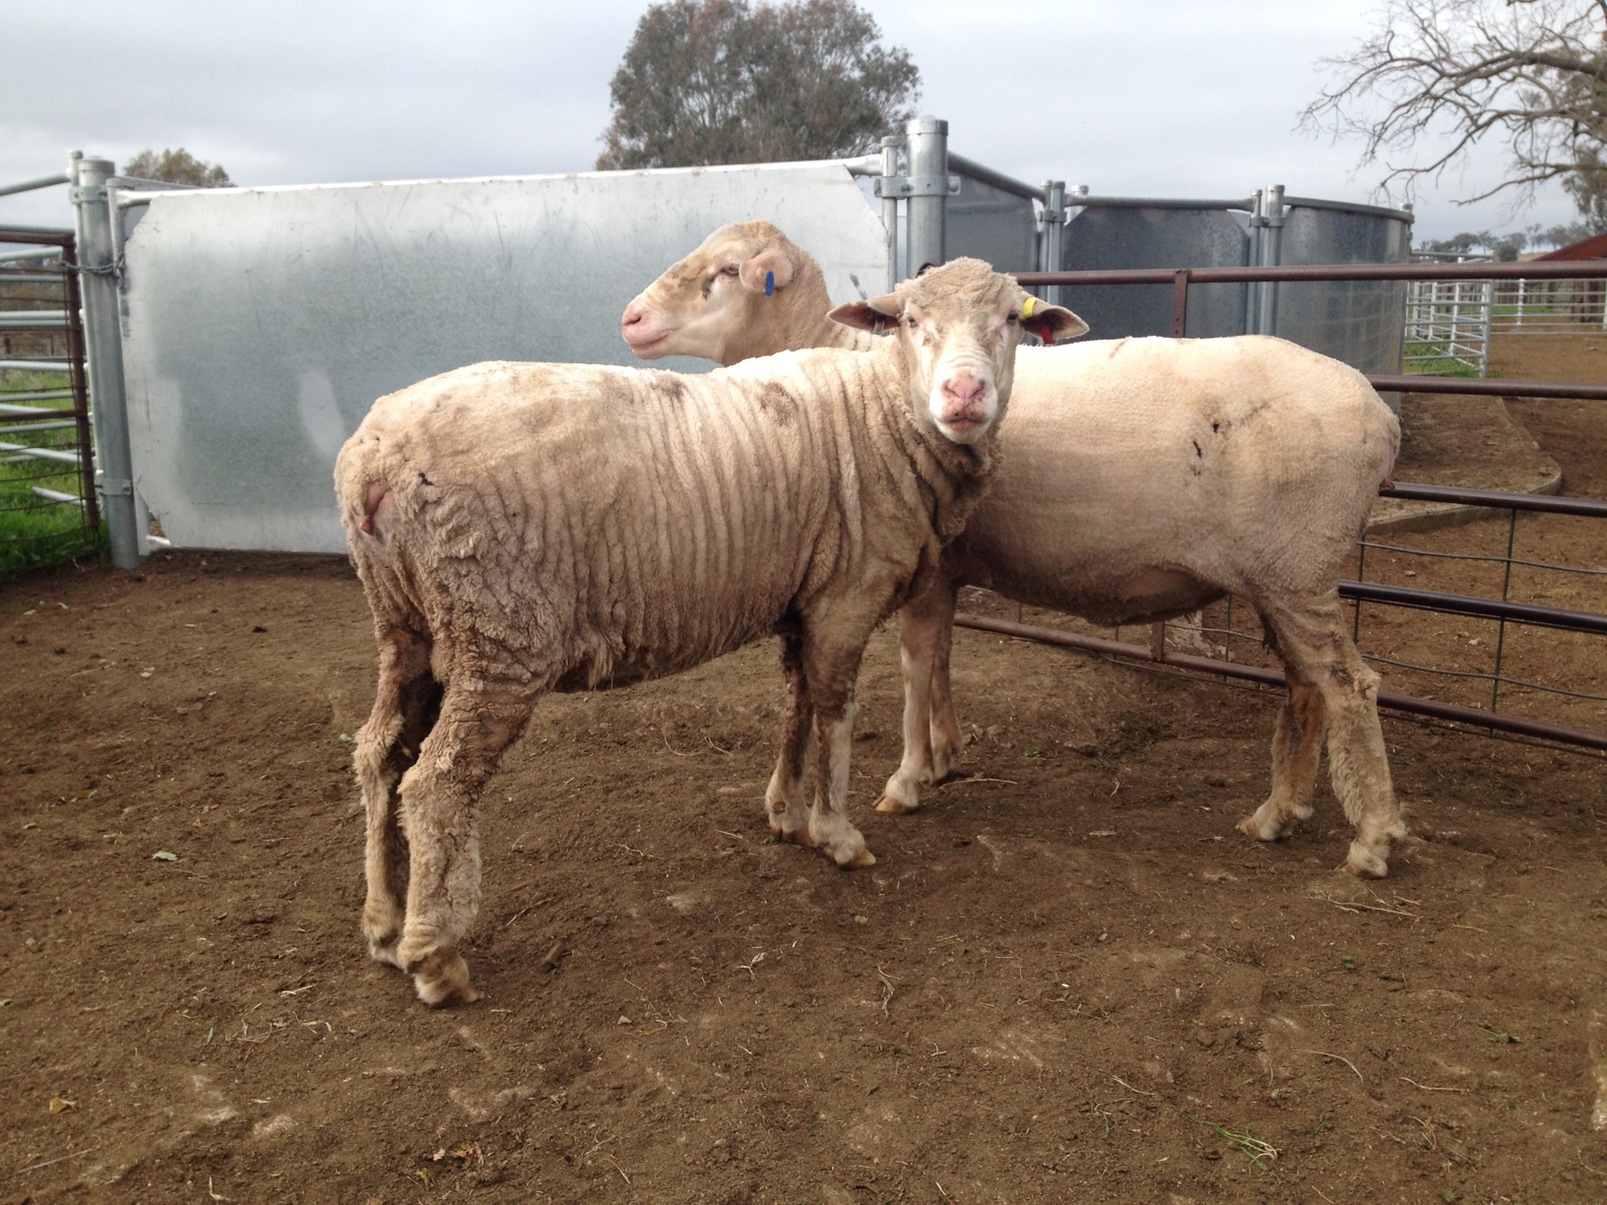

**Figure 7. Six year old Merino ewes from the same flock. The sheep (left) has a wrinkly skin. The sheep (right) is plain bodied. Both sheep produced 6 kilograms fleeces of 18.5 micron wool when shorn.**

1. **Fleece density**

The fleece structure of two SRS sheep, two semi SRS sheep, a “pretty wool” sheep and a“pin wrinkle” sheep from the same flock are shown in Figure 8.

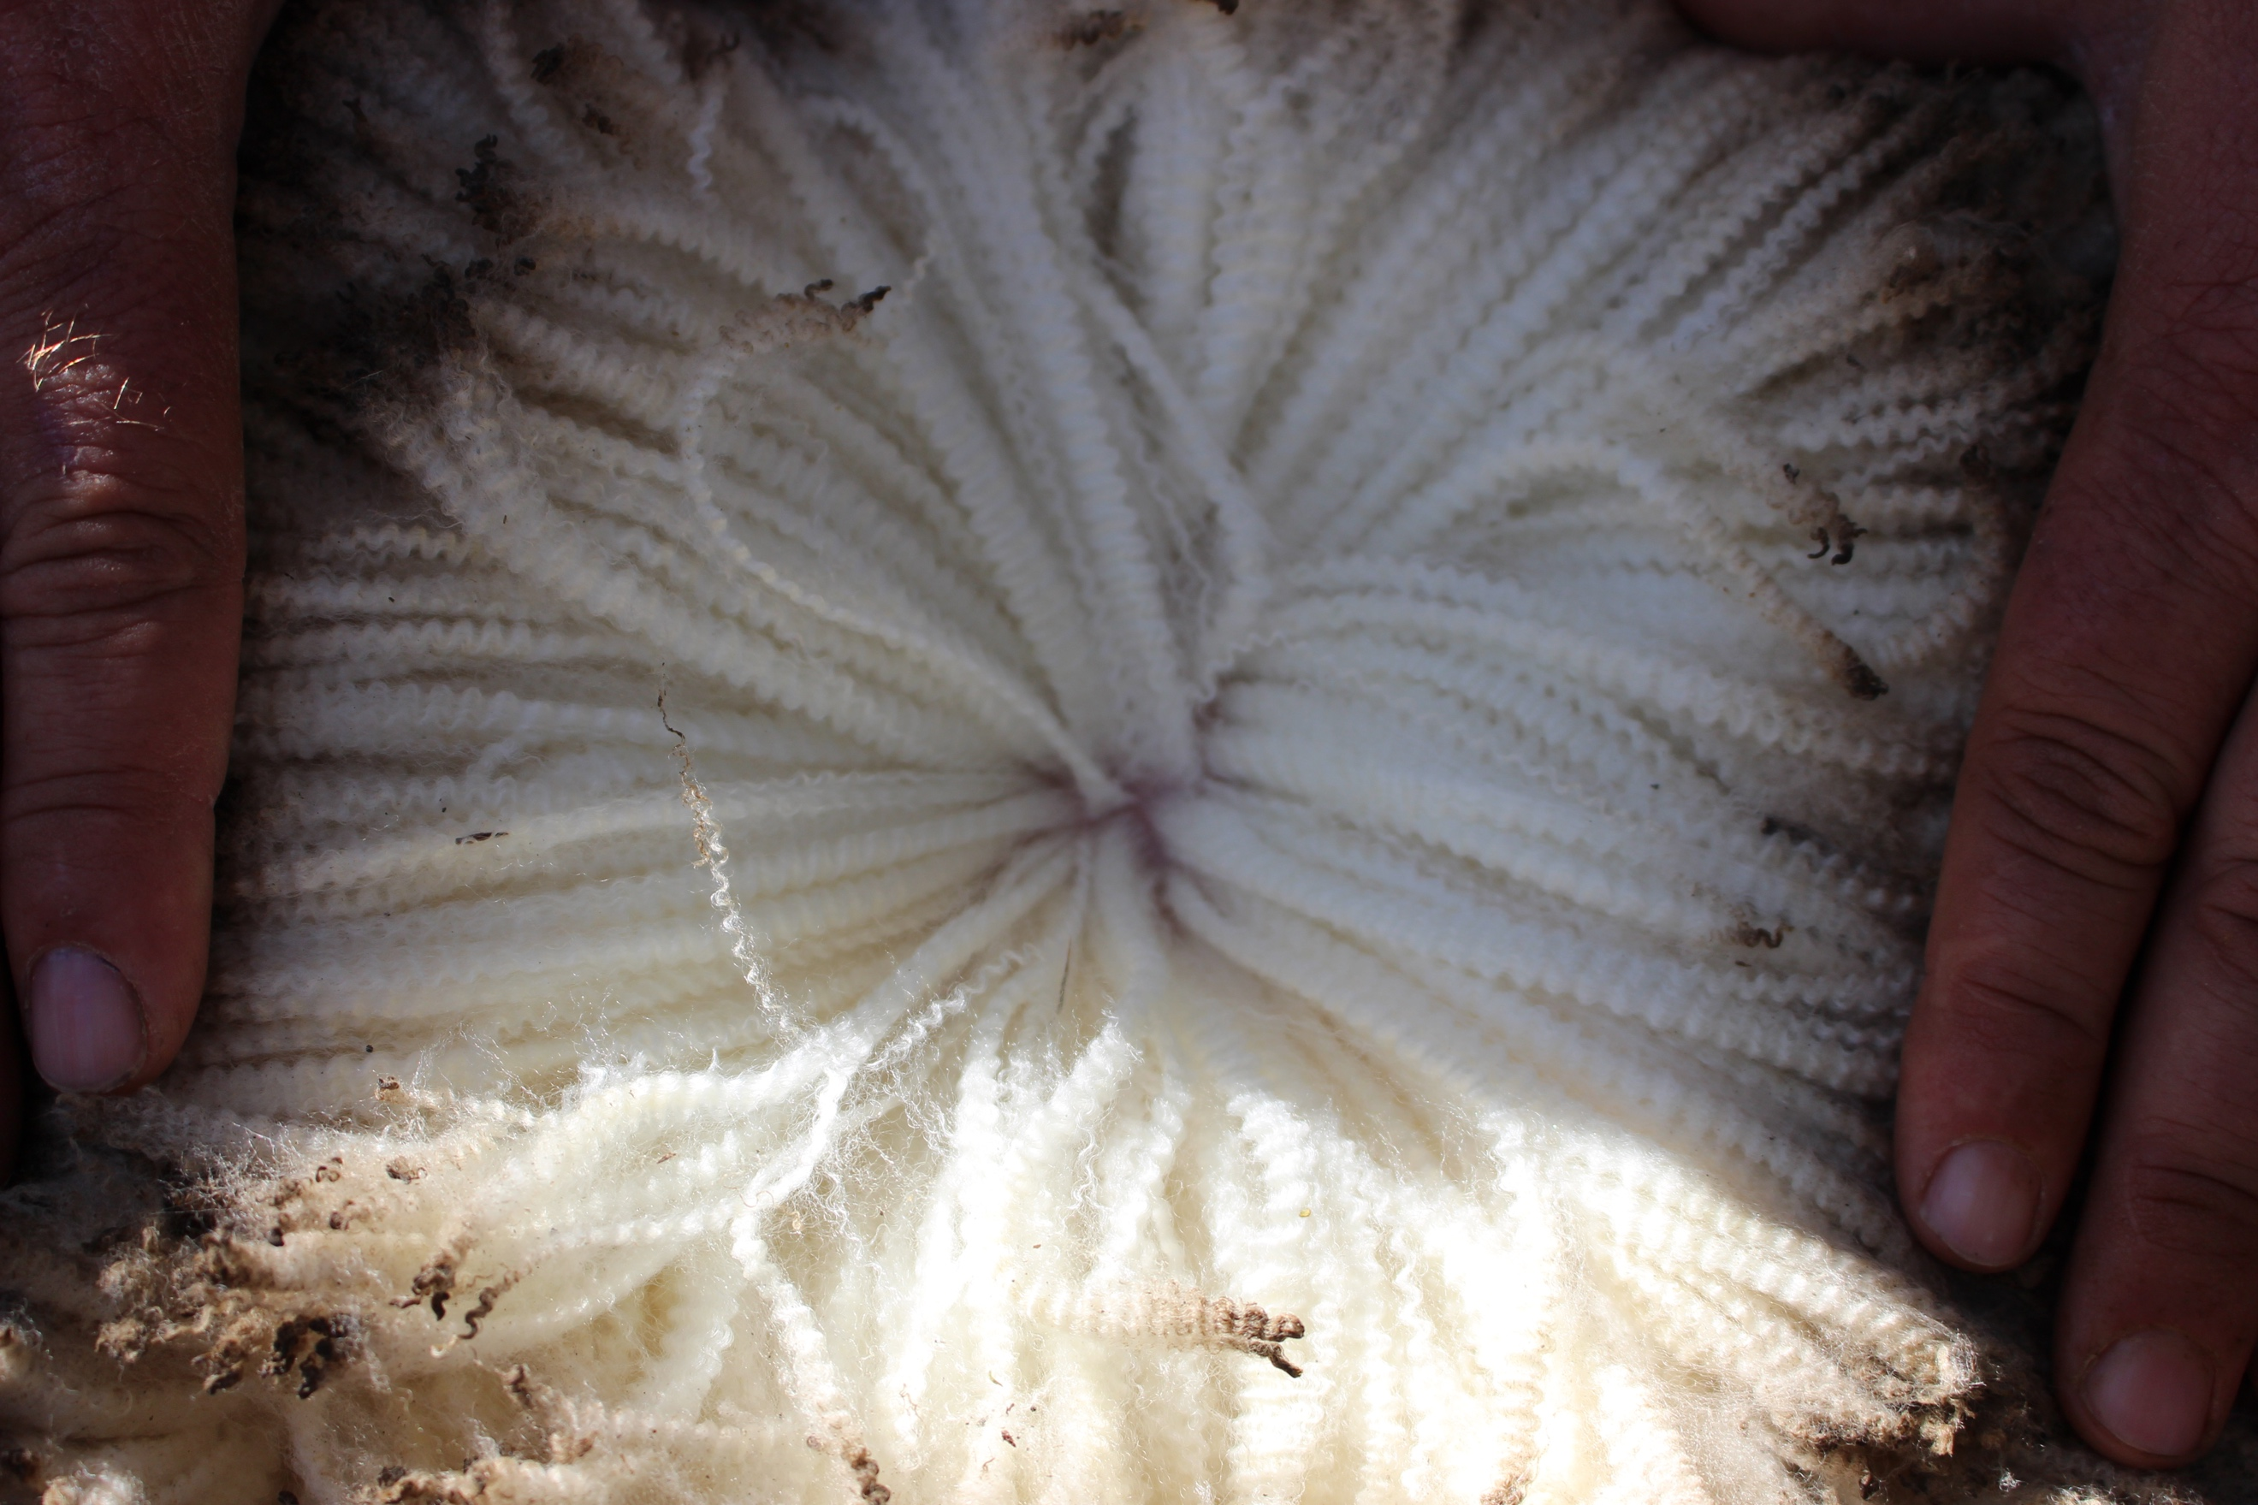

Arcadia 150134 Fn =

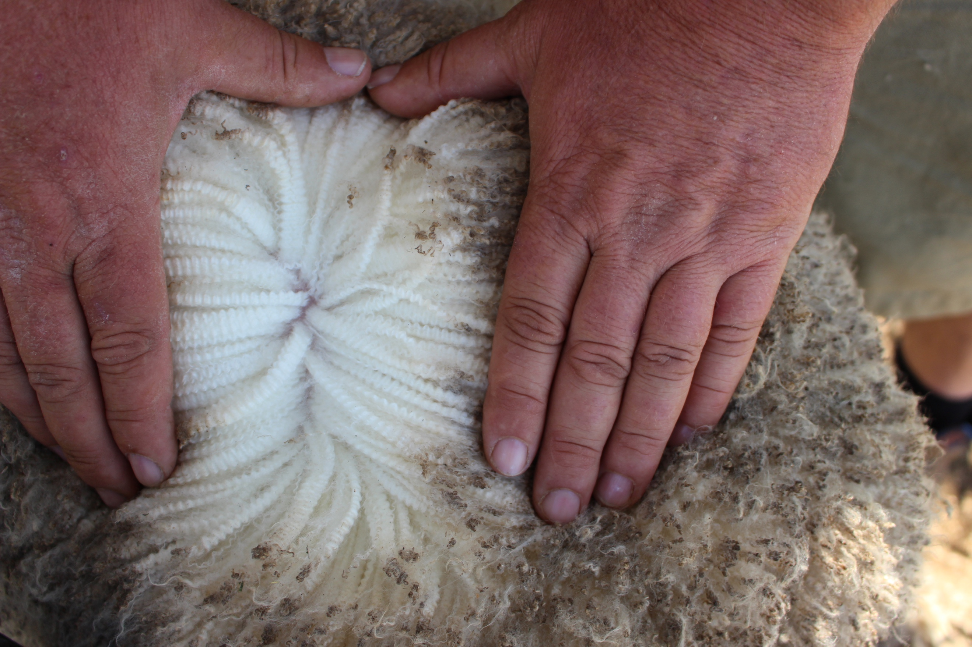

Arcadia 160221 Fn = 86

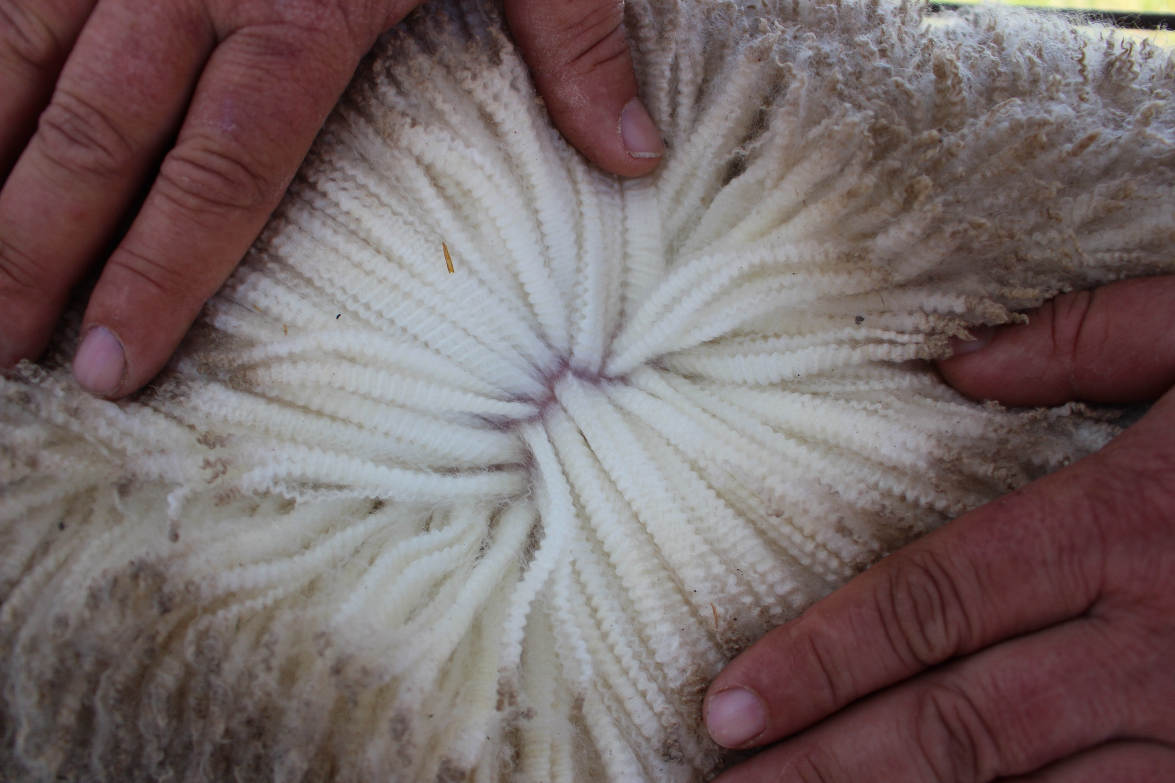

160107 Fn = 71

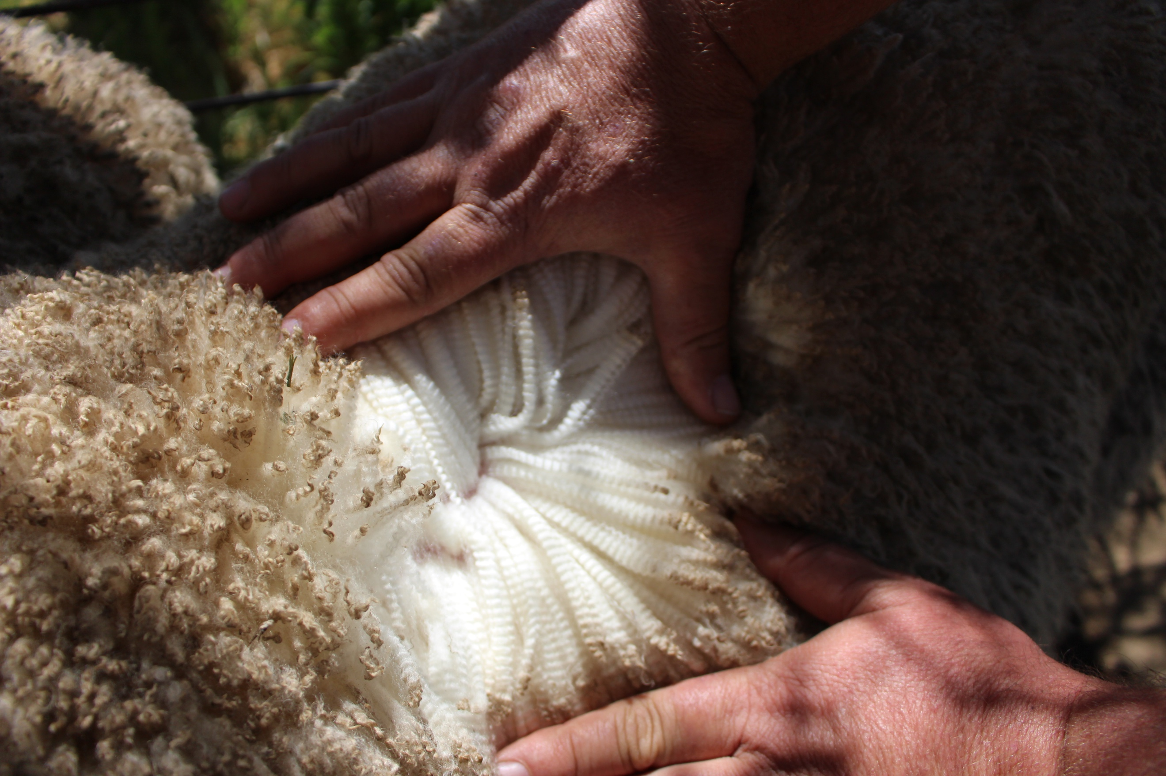

160447 Fn = 63

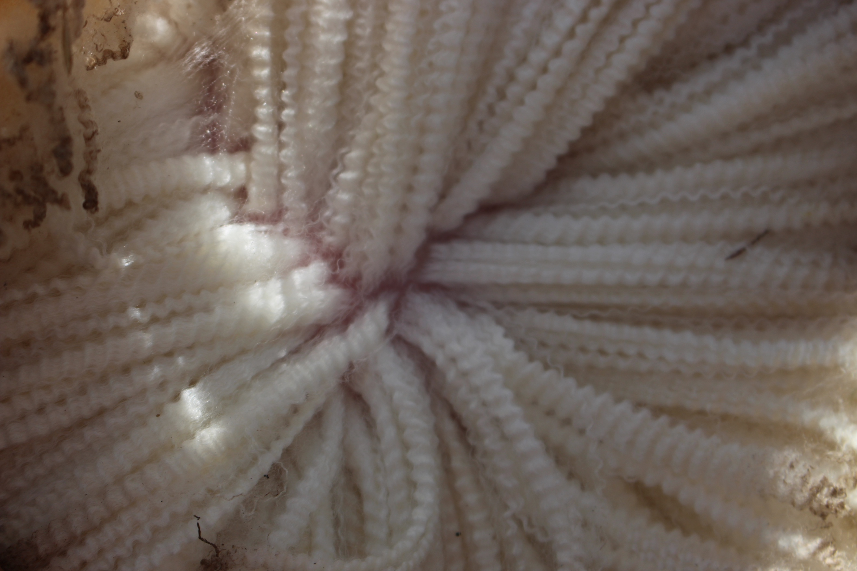

Arcadia 160450 IMG_1033.JPG Fn = 53

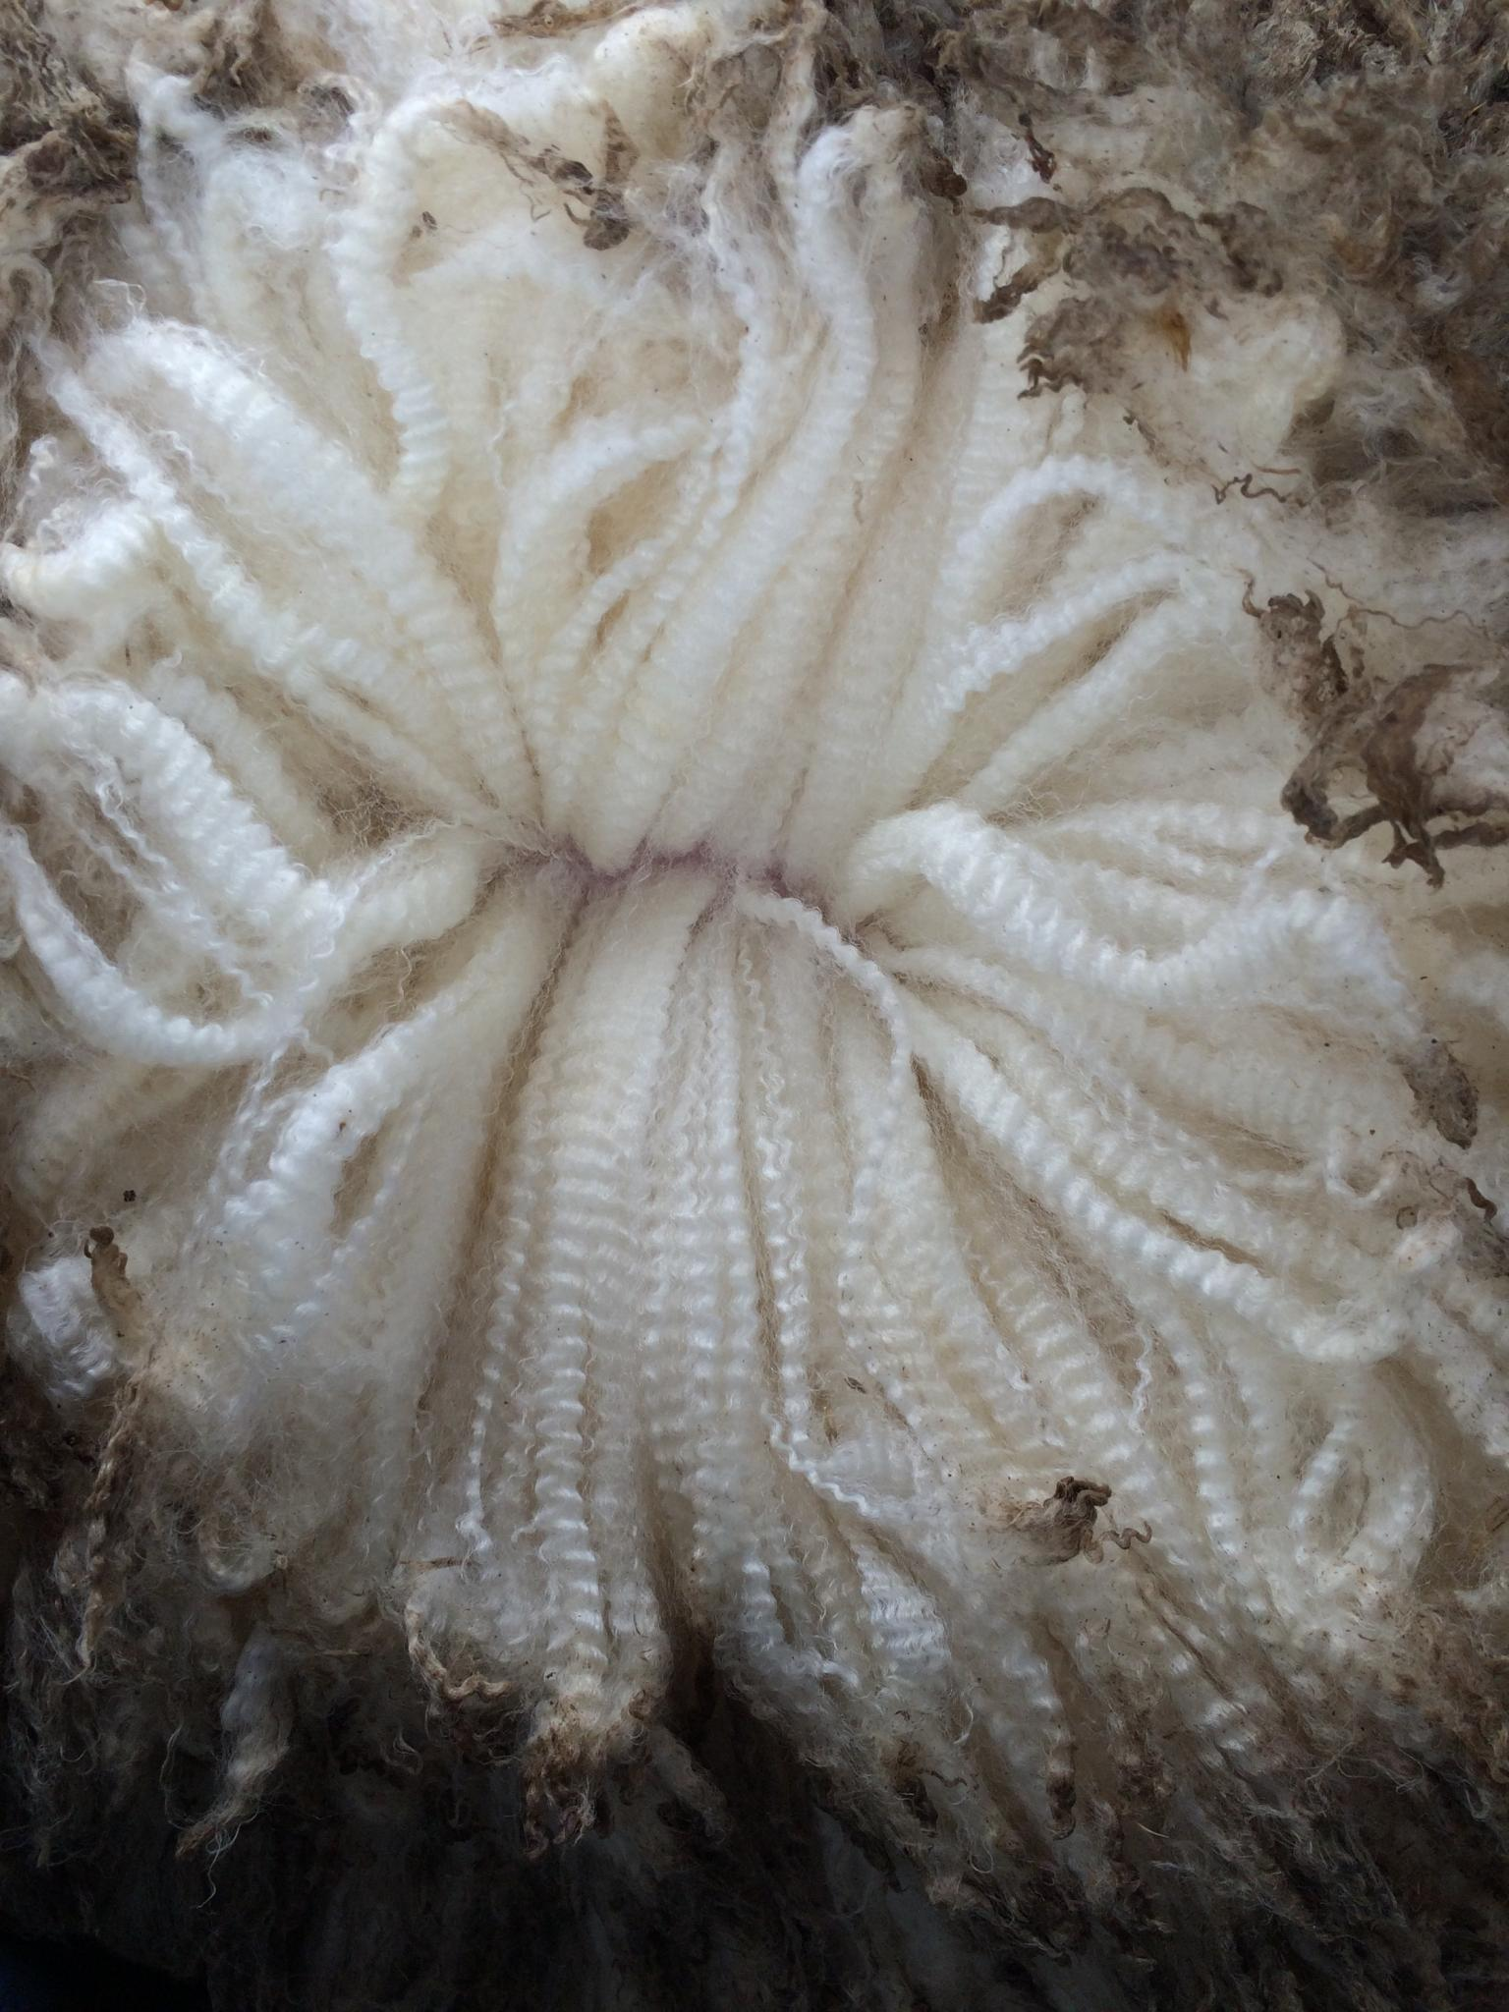

**Figure 8. Parted midside regions of, in descending order: two SRS sheep, two semi SRS sheep, and one “pretty wool” sheep from the same flock. The respective densities are ….., 86, 71, 63 and 53 follicles per square millimetre. The bottom photo is a”pink wrinkle” sheep of unknown density from another flock.**

The two SRS sheep have high densities of ….. and 86 wool follicles per square millimetre of skin and have formed thin staples (cross-sectional areas of …. and …. mm2 respectively). The two semi SRS sheep have intermediate densities of 71 and 63, and slightly larger staples of …. and …. mm2. The “pretty wool” sheep has a density of 53 and even larger staples of … cross-sectional area.

The “pin wrinkle” sheep has high variation in staple size. The thickest staples appear to be at least 10 times larger than the thinnest staples.

For all of these examples, the sheep appear to have well-defined crimp. On closer inspection, however, it is the SRS sheep that have horseshoe crimp, the semi SRS and “pretty wool” sheep that have semicircular crimp (not as pronounced as horseshoe crimp) and the “pin wrinkle” sheep that has a mix of semicircular crimp on the thinner staples and sine wave (least pronounced) crimp on the larger staples.

1. **Fibre bundles**

The SRS fleece in Figure 9 consists mainly of fibre bundles. It is from a five year old Merino fine wool ewe. The fleece weighs 8 kilograms for 12 months wool growth. The mean fibre diameter is 16.0 microns. The ewe has a density of 120 follicles per mm2 and a mean fibre length of 0.50 millimetres per day.



**Figure 9.**  This SRS Merino fleece (superfine wool) consists mainly of fibre bundles. Note the horseshoe crimp pattern.

As mentioned earlier, the fibre bundle is the cluster of fibres emerging from a follicle group in the skin (staple formation reference here). Its cross-sectional area, like that of the follicle group, is very small, about one square millimetre.

The fibre bundle is almost a defining feature of the SRS sheep and fleece. It is occasionally seen in “pretty wools”. Fibre bundles form when the distance between wool follicles is very low. Watts (unpublished data) has shown this distance averages … microns in SRS sheep and … microns in “pretty wool” sheep with fibre bundles. In sheep which only form staples, the interfollicular distance averaged ….. microns.

1. **Follicle patterning**

The wool follicles of SRS sheep are arranged as orderly and well-spaced rows of compact follicle groups in the skin (Figure 10). There are high numbers of follicles per group.





**Figure 10.**  Horizontal skin sections from SRS (top) and semi SRS (bottom) Merino sheep. Examples of follicle groups are highlighted by dotted lines. The SRS sheep has orderly rows of follicle groups separated by wide laneways. The semi SRS sheep has slightly disrupted rows of follicle groups with narrow laneways. Stained with 0.5 % Nile blue sulphate. Microscope magnification 25 x.

A field survey of the follicle and fibre traits of 812 Merino stud rams in 45 flocks throughout Australia was carried out between 1986 and 1995 (Watts et al, 2017). SRS sheep had a mean density of 84.0 follicles per square millimetre, or 25 %, 51 % and 53% higher than the semi SRS sheep, wrinkly skin and flat skin sheep respectively. The S/P ratios of the SRS phenotype had a mean value of 44.1, or 29 %, 54% and 78% higher than the other phenotypes respectively. The primary fibre diameter of the SRS phenotype had a mean value of 18.9 microns, or 0.9, 4.0 and 3.4 microns finer respectively than the other phenotypes. The secondary fibre diameter of the SRS phenotype had a mean value of 20.4 microns, or 1.3, 4.2 and 3.6 microns finer respectively than the other phenotypes.

1. **Fleece and fibre length**

SRS Merino sheep grow very long fleeces at the rate of 15 to 20 millimetres per month (Figure 11). The fibre length to staple length ratio is usually greater than 1.4 to 1, and overall, the mean growth rate of the fibres is very high at 0.6 to 0.8 millimetres per day.



**Figure 11.** SRS Merino fleece (medium wool) is 108 millimetres long, 6.2 kilograms, and 16.6 microns for 7 months growth. The follicle density is 92 follicles per square millimetre*.*

1. **Crimp**

The SRS fleece has high crimp amplitude (“deep” crimp) and low crimp frequency (“bold” crimp). It is a horseshoe shaped crimp. The crimp waves usually form unfolded helices (Figure 12).



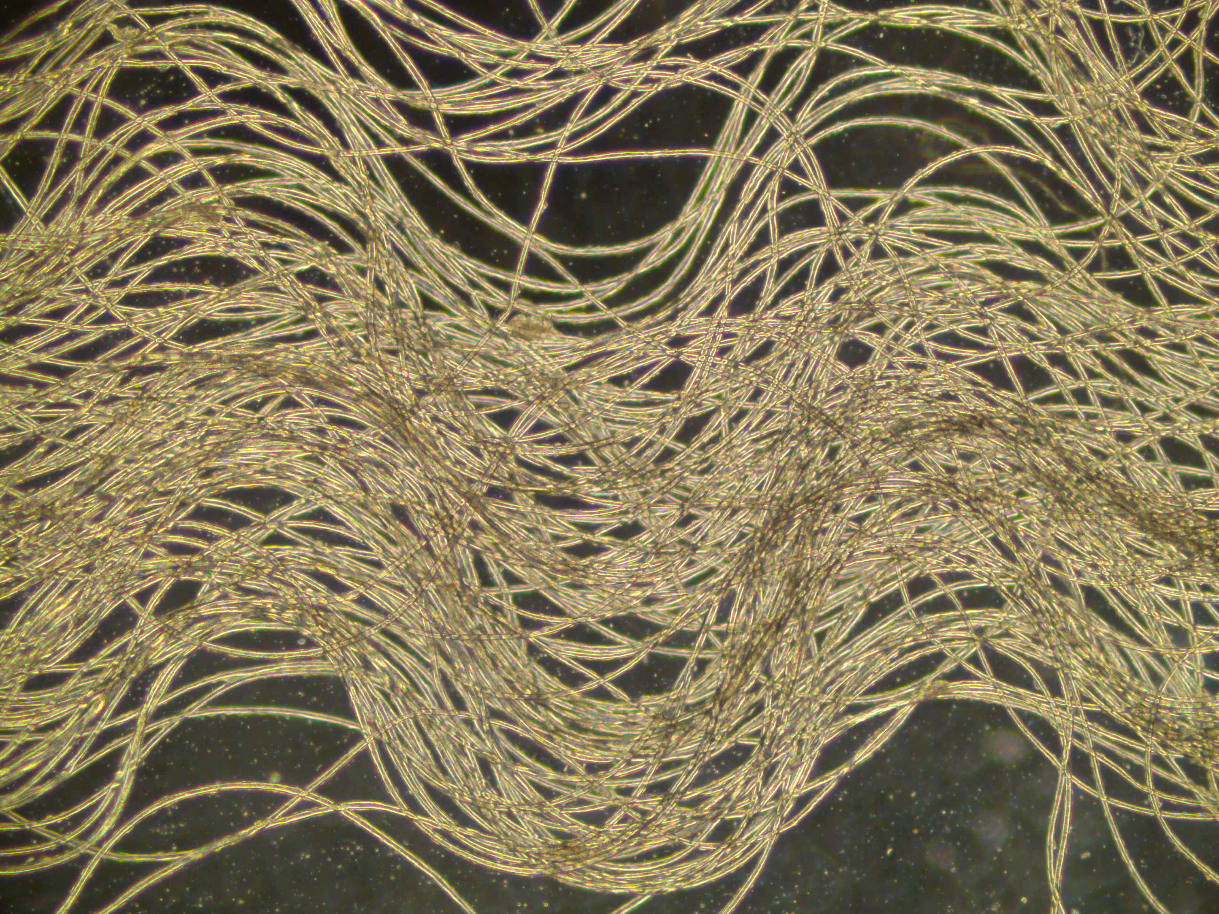

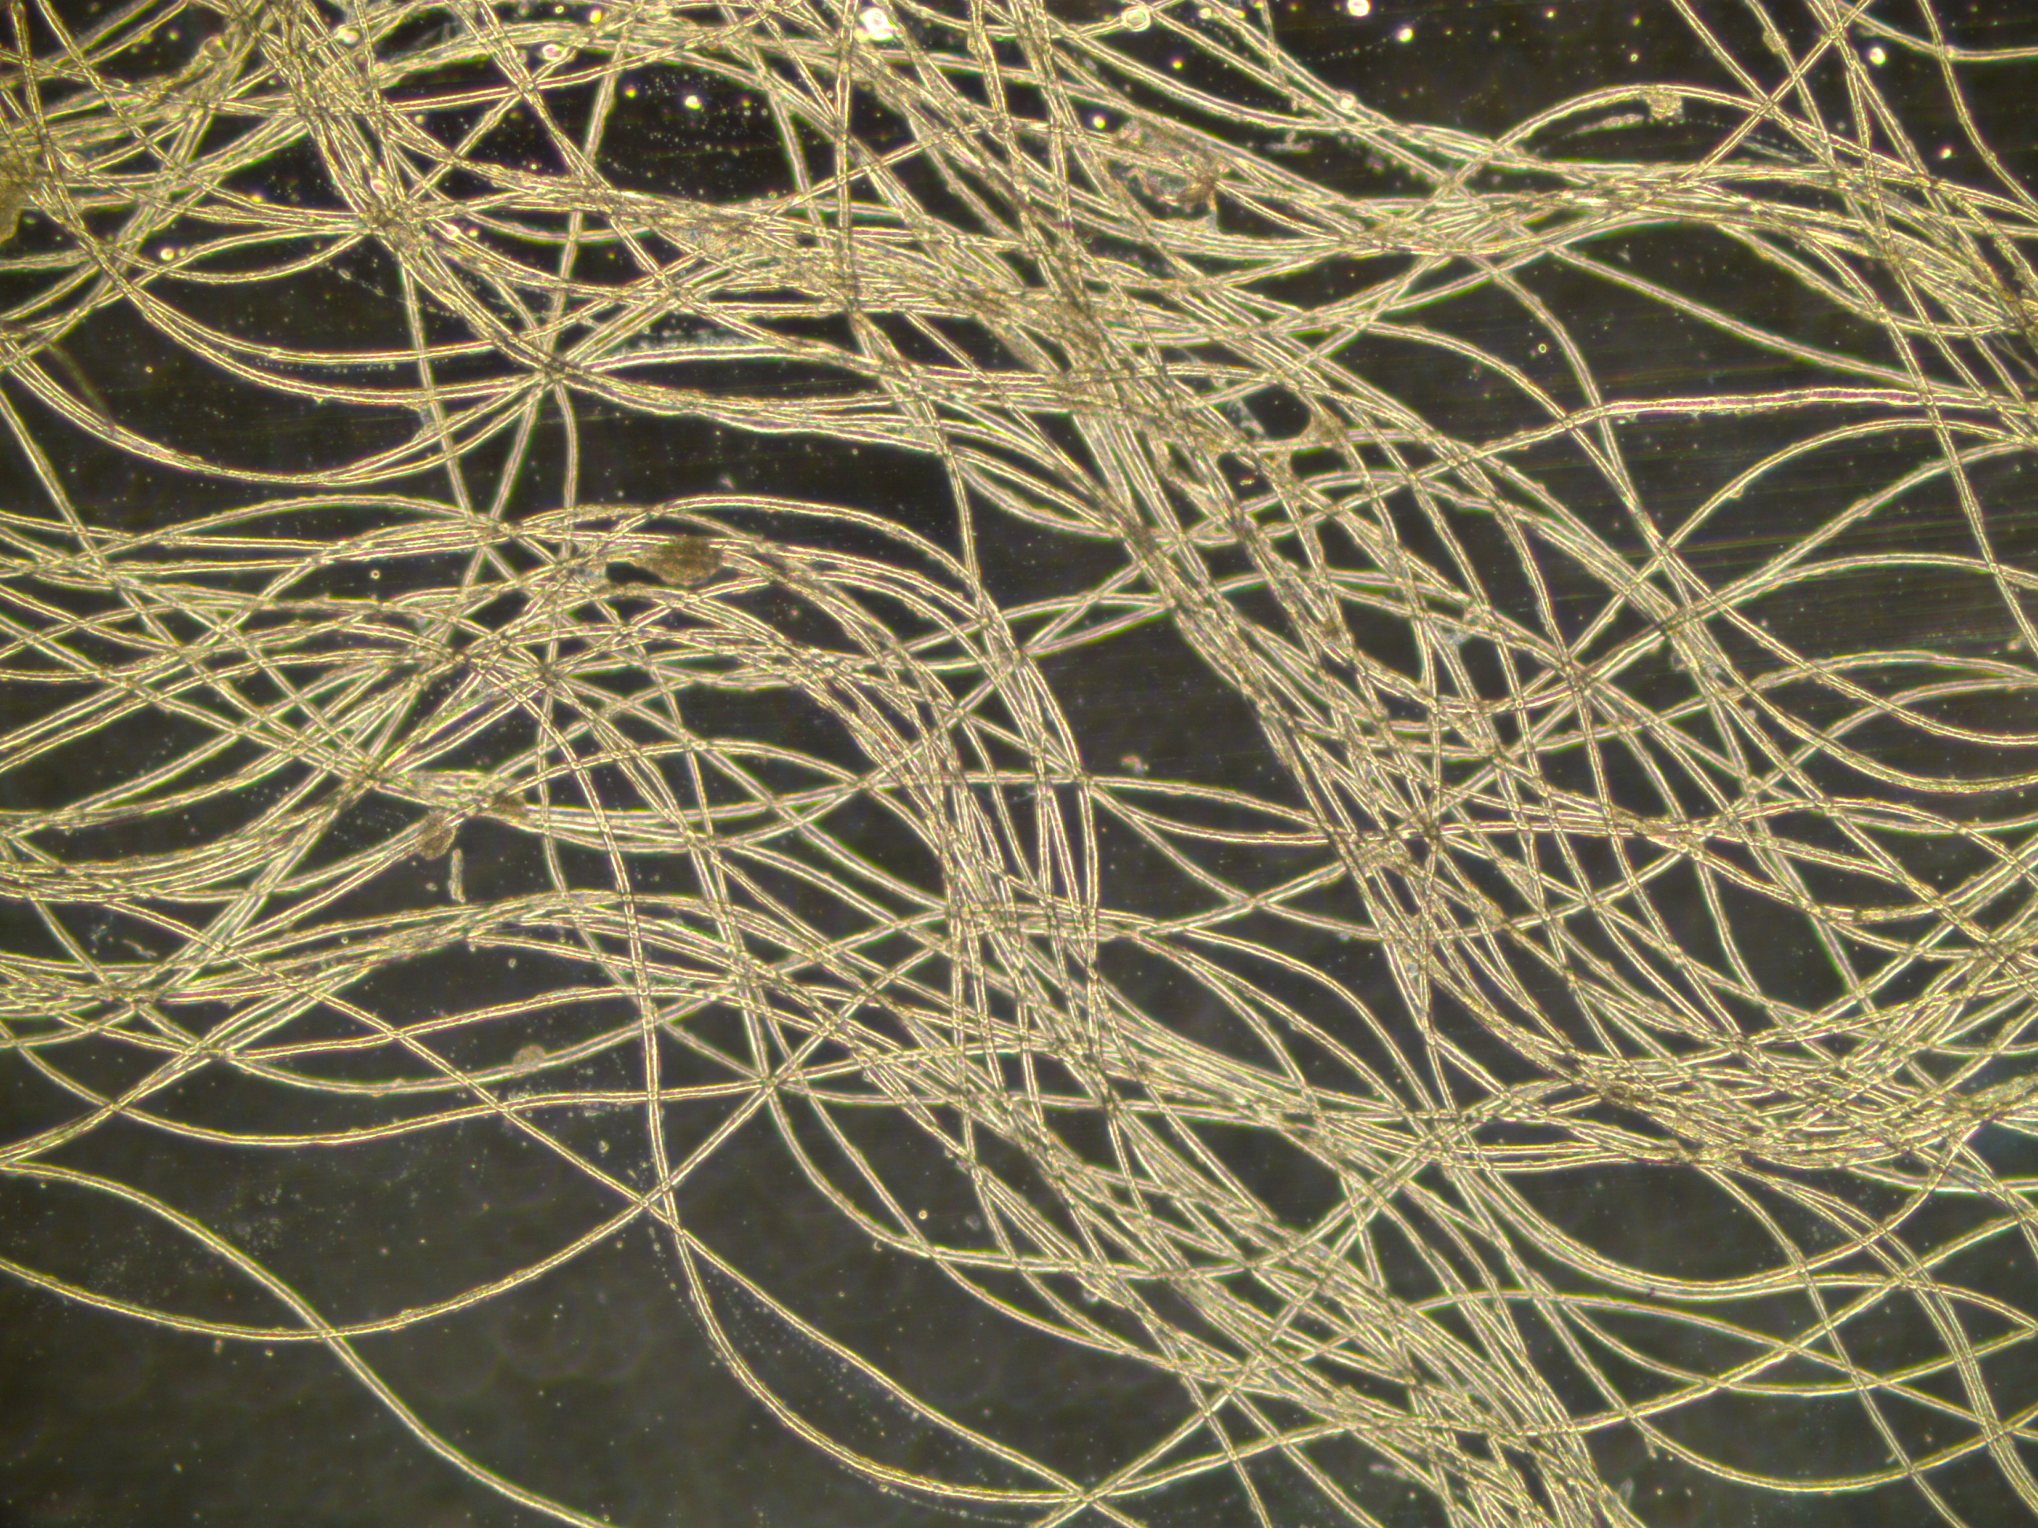

**Figure 12. Top: crimp waves of SRS wool are usually unfolded helices. The fibres twist abruptly at the points of inflection (see arrows) on either side of the crimp wave. Middle: the crimp waves of non SRS wools invariably form stretched helices. The abrupt twisting of fibres does not occur. Bottom: Unaligned fibres (finalunlignedfibres2.jpg) Magnification x …. (Neville Jackson 14525c.tif 2.4 MB; Neville Jackson Final 14549.jpg)**

An unfolded helix forms when a cluster of highly aligned fibres twist in unison at localised and regular sites along the crimp wave. The phenomenon is described by Jackson and Watts (2017).

1. **No fly strike and no mulesing**

The 16 months old rams shown in Figure 13 are semi SRS Merinos carrying 8 months wool growth. The sheep have been exposed to 380 millimetres of rain over 6 weeks during the hot, summer months from December to early January. The wool has remained white with no fleece rot or body strike. The sheep are not mulesed.



**Bruce Coppock IMG_ 1373. JPG**

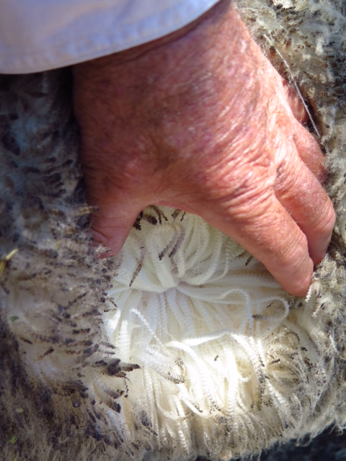

**Bruce Coppock IMG_1378 JP**

**Figure 13. Top: note the 16 months old semi SRS Merinos in the foreground. It is carrying 8 months wool growth. Bottom: the same ram has white wool with no signs of fleece rot, bacterial stain or yellowing.**

The young SRS and semi SRS rams in Figure 14 have no skin wrinkling over the tail, in the breech region, or down the backlegs. The perineal region has formed a large, wool free region referred to as a “bare breech”.



**Arcadia IMGP8960 - cropped**

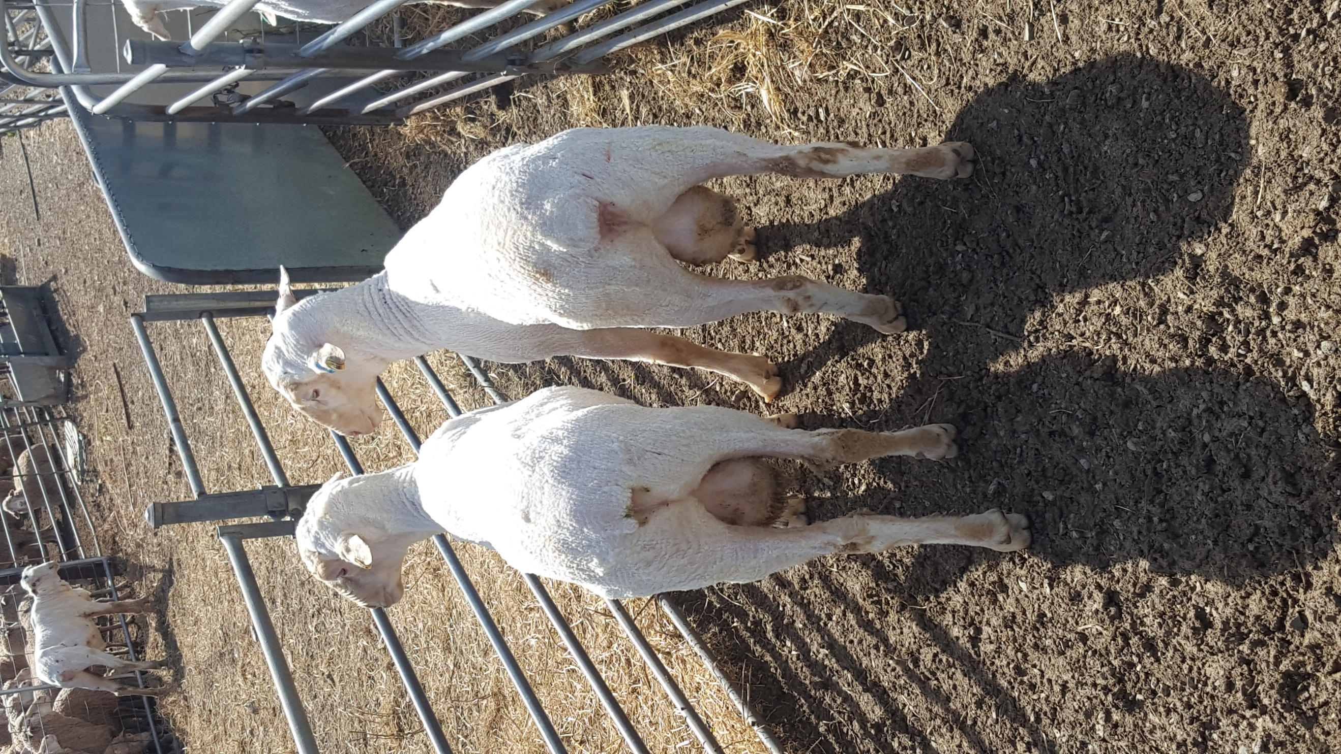

Baderloo 2016102… re breech

**Figure 14. Top: Twelve months old rams carrying 5 months wool. The ram on the left has been crutched Bottom: Twelve months old rams, recently shorn, with wrinkle free and bare breeches.**

1. **Summary**

The concept is presented that the skin needs to be loose, not fixed, to avoid skin wrinkle formation in sheep with high secondary follicle development.

SRS Merino sheep are described as being plain bodied sheep with a loose and highly expansive skin and a fleece consisting of very long and closely packed fibre bundles and thin staples with horseshoe crimp. These features are held to be reliable visual markers of high fibre density and length. Photographic standards are included to show the appearance of the whole animal, its fleece surface, fleece structure and skin type.

Subtle differences in the gross appearance of the SRS sheep can be detected visually. When the loose skin becomes moderately expansive, fibre bundles are no longer seen in the fleece, the thin staples become slightly larger, and the horseshoe crimp is replaced by a semicircular crimp, we say the sheep is a “semi SRS” phenotype. Measurements indicate that the high levels of density and length of the SRS phenotype have decreased by about 20 % and 10 % respectively. Semi SRS and SRS sheep are included in a breeding program, unless unrelated traits disqualify the animal.

A third loose skin type, referred to as the “pretty wool” phenotype, is again easily recognised visually. It is a plain bodied sheep but it displays a further trending downwards of the semi SRS markers. It is usually culled for low fleece weight.

And three other phenotypes, all with fixed rather than loose skins, are described briefly. These are referred to as “wrinkly” sheep, “pin wrinkle“ sheep and “flat skin” sheep. These phenotypes have markedly different descriptions for skin and fleece markers to the three phenotypes with loose skins, and are not included in breeding programs.

1. **References**

Jackson, N., and Watts, J.E. (2016). Staple crimp formation in the fleece of Merino sheep.

Jackson, N. and Watts, J.E. (2018). Does follicle development affect the spatial layout of sheep’s skin ?

Watts, J.E., Jackson N., Ferguson, K.A. and Moore, G.P.M. (2018). Fleece structure and its relation to histological skin characteristics of Merino stud rams in Australia.